**TOPIC-** EASTER

**Lesson 3.3 The Resurrection**

**Age Group:** 1-5, 6 - 7, 8-13

* Opening Prayer, Worship and Praise
* Review of the previous lesson
* **Objective:**

In this lesson, the children will learn the Christian faith is centered on the resurrection of Jesus Christ. Children will also discover that God gives believers victory over death and sin through the death and resurrection of His Son, Jesus Christ.

* **Bible Story Reference:** Luke 24:1-12; Luke 24:13-35; Luke 24:36-49(NIV)
* **Introduction**

Easter to Us christains is the most important celebration of the year. Easter also reminds us of what Jesus did on the cross for us. It reminds us that God fulfilled His promises and sent us a savior to die for our sins.

What appears to be one of the darkest times in all of human history becomes the most joyful, as the world discovers that Jesus has conquered sin and death.

* **Bible Story:** Luke 24:1-12; Luke 24:13-35; Luke 24:36-49

* **Questions for Discussion**

**Read Luke 24:1-12**

**1. Who were the men in clothes that gleamed like lightning?** *(Angels.)*

**2. What did the angels say to the women?** *("Why do you look for the living among the dead? He is not here; he has risen!")*

**3. What did the women do when they returned from the tomb?** *(They told the others what they had seen.)*

**Read Luke 24:13-35**

**1. Who appeared to two of Jesus' followers while they were on the way to Emmaus?** *(Jesus.)*

**2. Were these two able to recognize that it was Jesus walking with them?** *(No, they were kept from recognizing Him.)*

**3. When asked, what did these two say they were discussing as they traveled to Emmaus?** *(They were talking about the crucifixion and resurrection.)*

**4. When were they able to recognize that Jesus was with them?** *(Their eyes were opened as Jesus took bread, gave thanks, broke it, and began to give it to them.)*

**5. What did these two do after Jesus disappeared?** *(They returned to Jerusalem to tell Jesus' other followers what happened.)*

**Read Luke 24:36-49**

**1. Who appeared to the group of followers while they were discussing what happened on the road to Emmaus?** *(Jesus.)*

**2. What did Jesus do to ease their fears and remove their doubt?** *(He showed them His hands and feet. He also ate some fish.)*

**3. Why did Jesus open their minds?** *(So that they could understand the scriptures and begin preaching the Gospel.)*

* **Memory Verse: Acts 2:32 (NIV)**

"God has raised this Jesus to life, and we are all witnesses of it."

* **Application and Conclusion**

As Christians, our faith is centered on the resurrection of Jesus Christ. We rejoice, knowing that Jesus Christ has indeed risen from the dead, giving believers victory over sin and death. The Bible says, "'Where, O death, is your victory? Where, O death, is your sting?' The sting of death is sin, and the power of sin is the law. But thanks be to God! He gives us the victory through our Lord Jesus Christ. Therefore, my dear brothers and sisters, stand firm. Let nothing move you. Always give yourselves fully to the work of the Lord, because you know that your labor in the Lord is not in vain." 1 Corinthians 15:55-58. We, like Christ's early followers, should joyfully share the Good News of Jesus' resurrection with those around us.

* **Activities Attached:**
  + Two sets of activities
  + The Crucifixion Video: <https://www.youtube.com/watch?v=IH0vBClMk5A&feature=emb_logo>
* **Closing Prayer**

**Activity 1**

He Has Risen (Puzzle)

***(Word Search) Children search for words related to Jesus rising from the dead.***

**HE HAS RISEN** (Word Search) Children search for words related to Jesus rising from the dead.

**MATERIALS:**

Word puzzle for each child

Pencils or markers

**DURATION:**

Approximately 10 minutes

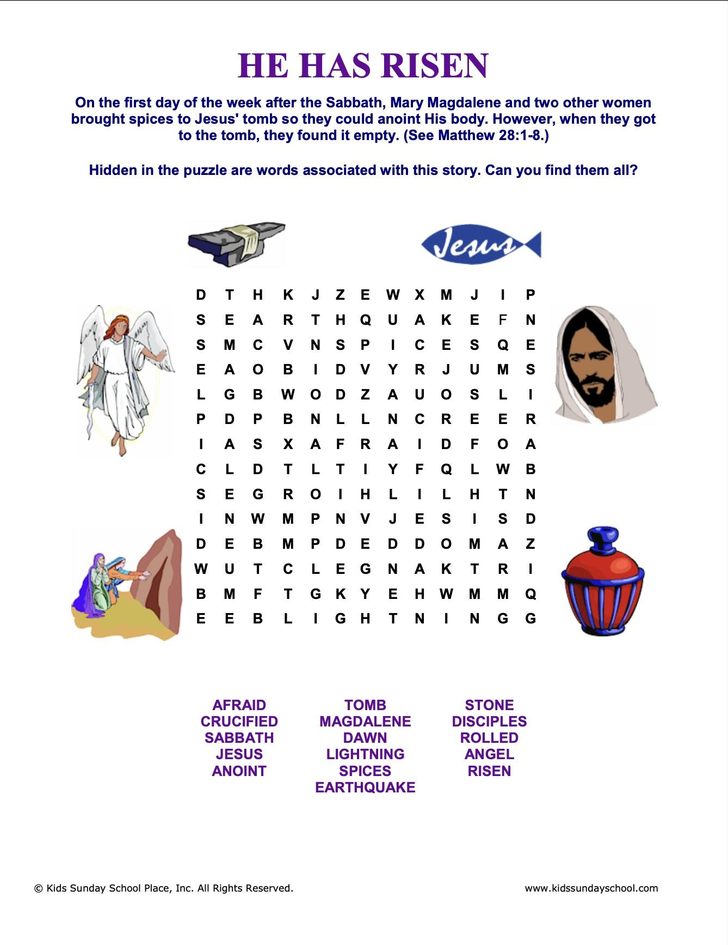

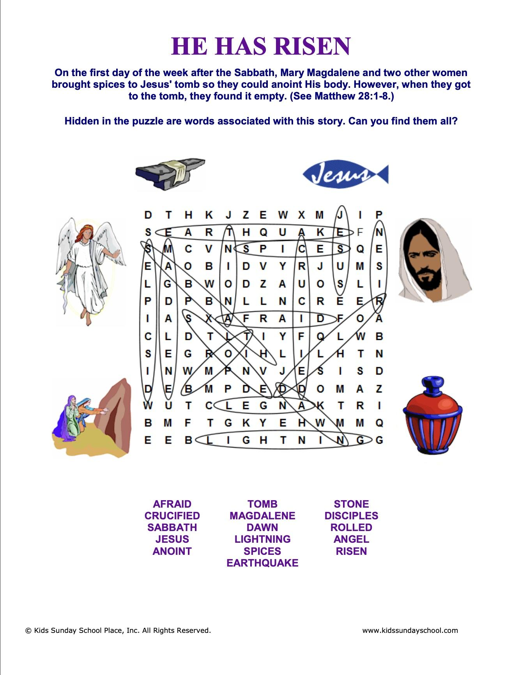

**Activity 2 - Easter Skit**

A skit between two boys and the real reasons for celebrating Easter. (A skit for two persons: Josh and Buddy.)

|  |  |
| --- | --- |
| DURATION:  Approximately 10 minutes |  |

|  |  |
| --- | --- |
| **Josh:** | Hey Bud, you know Easter is coming. Are you doing anything special? |
|  |  |
| **Buddy:** | I hope so. |
|  |  |
| **Josh:** | Hmm. Hey, what are you doing with those leaves? |
|  |  |
| **Buddy:** | They're not just leaves: they're palm leaves. |
|  |  |
| **Josh:** | I know they're palm leaves, but what are you doing, making a cross? |
|  |  |
| **Buddy:** | Yep. For Easter. |
|  |  |
| **Josh:** | *(Rolling his eyes)* Very interesting. |
|  |  |
| **Buddy:** | Doesn't your family go to church on Easter? |
|  |  |
| **Josh:** | Sometimes. Usually we go to my grandma's house to hunt for eggs and eat all kinds of stuff. |
|  |  |
| **Buddy:** | Easter has a special meaning too, besides hunting eggs and eating food. |
|  |  |
| **Josh:** | What else could there be? I know about Jesus and the Easter celebrations in churches. I went to one church where the people waved palm leaves around. It was pretty cool looking. |
|  |  |
| **Buddy:** | Did you know Jesus died for you? |
|  |  |
| **Josh:** | Okay Mr. Priest, Pastor, or whatever. I better get going. |
|  |  |
| **Buddy:** | Wait! I just want you to know why we celebrate Easter. Jesus died on the cross as an offering for our sins, so people who believe and have faith in Him will be saved. |
|  |  |
| **Josh:** | Well, why would Jesus die for me on Easter? And, why would I want to be saved? Saved from what? |
|  |  |
| **Buddy:** | Do you believe in God? |
|  |  |
| **Josh:** | Sure, of course. I know there is a God, and I know I'll go to Heaven. You know me; I'm a good person. |
|  |  |
| **Buddy:** | *(Smiling)*I know you're a good person, but are you perfect? |
|  |  |
| **Josh:** | No, but who is? I don't think anybody is perfect, even my mom and dad aren't perfect. |
|  |  |
| **Buddy:** | Exactly. But, to be with God in Heaven, you have to be perfect. |
|  |  |
| **Josh:** | But, we just agreed that nobody's perfect. So if you have to be perfect, then nobody is going to Heaven. How dumb is that? |
|  |  |
| **Buddy:** | That's why Jesus died on the cross. He is perfect, and He gave Himself to die like a sacrificial lamb, so we can be united with God through Him. |
|  |  |
| **Josh:** | But, Jesus was just a man who died on a cross. |
|  |  |
| **Buddy:** | He did. But then He proved He was God when He rose from the dead on the third day. He conquered death! That is why we celebrate Easter. |
|  |  |
| **Josh:** | And how do you know all of that? |
|  |  |
| **Buddy:** | You can read about it in the Bible. And, you can learn a lot about Jesus by going to Sunday school. |
|  |  |
| **Josh:** | Hmm. I didn't know any of that. But I'm still confused about the Jesus being God thing. |
|  |  |
| **Buddy:** | Do you want to go with me to Sunday school to learn more? |
|  |  |
| **Josh:** | Maybe. Hey, could I go on all those trips you guys have, like rafting and camping? |
|  |  |
| **Buddy:** | Sure. Also, if you come, you'll make a lot of friends, especially Jesus. |
|  |  |
| **Josh:** | Huh? I thought He was up in Heaven. |
|  |  |
| **Buddy:** | Josh, Josh, Josh. You need to read your Bible! |
|  |  |
| **Josh:** | *(Laughing.)*What? First, you want me to go to Sunday school and now you want me to read too? That's stretching it. |